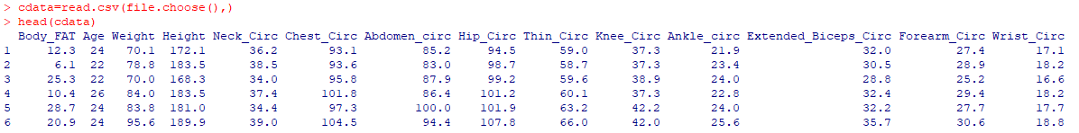

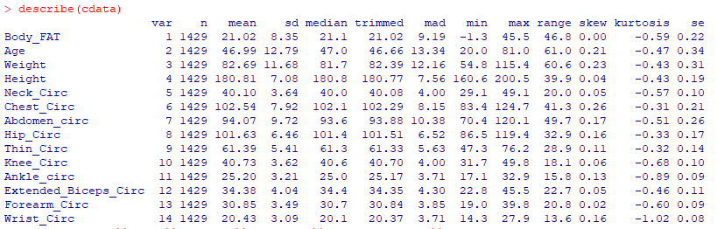

**Visual EDA:**



Histogram:

> hist(cdata$Neck_Circ)

> hist(cdata$Chest_Circ)

> hist(cdata$Abdomen_circ)

> hist(cdata$Hip_Circ)

> hist(cdata$Thin_Circ)

> hist(cdata$Knee_Circ)

> hist(cdata$Ankle_circ)

> hist(cdata$Extended_Biceps_Circ)

> hist(cdata$Forearm_Circ)

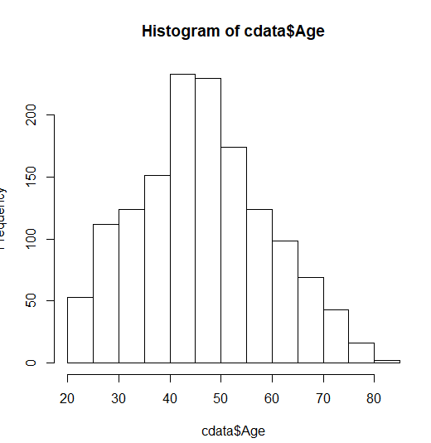 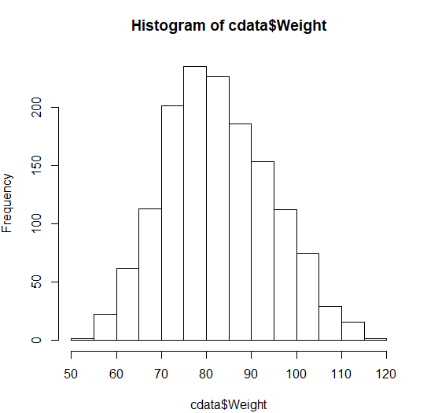 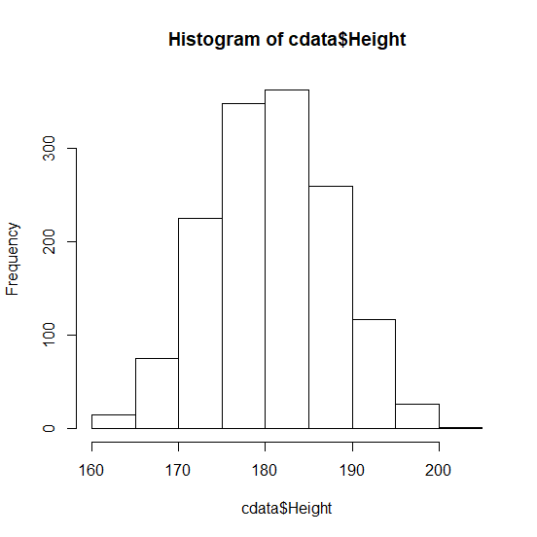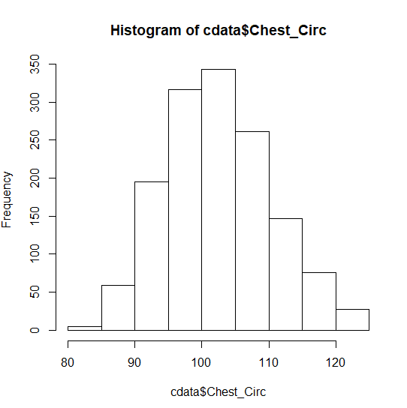 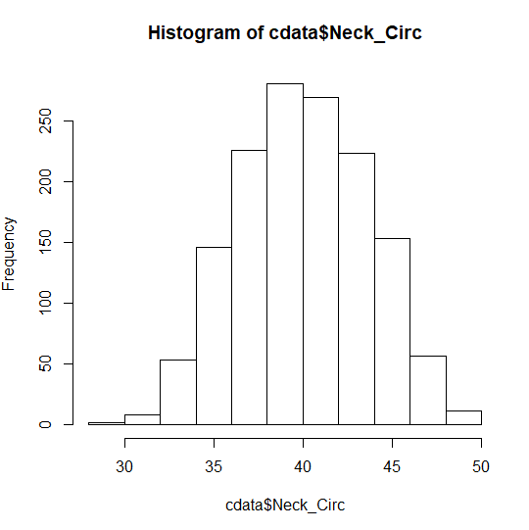 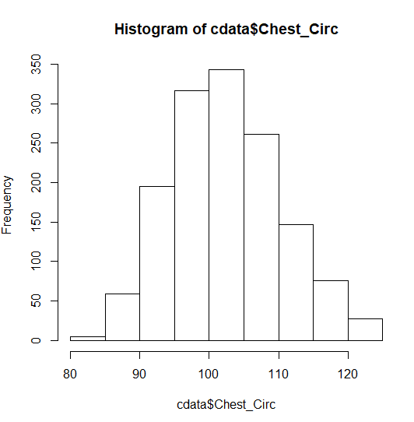

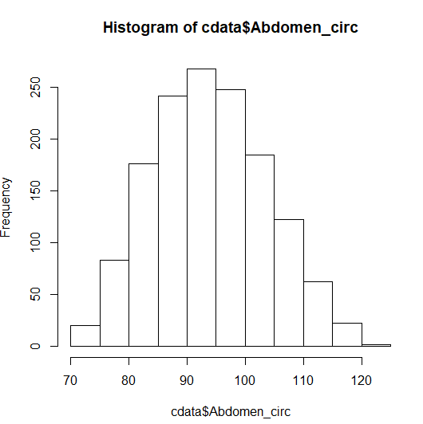 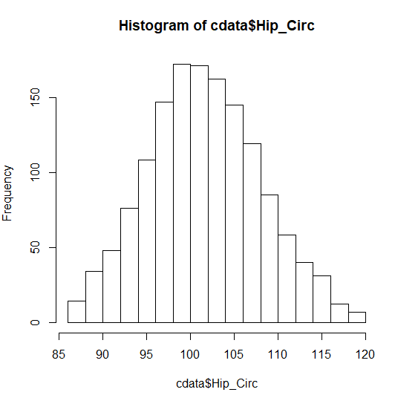 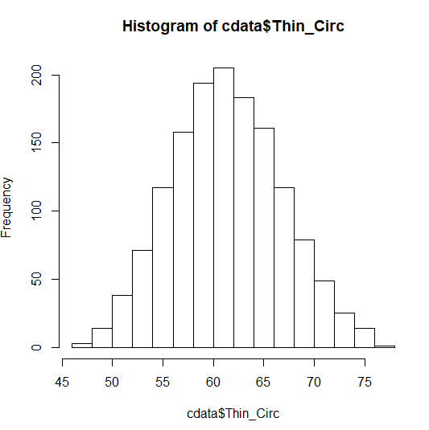

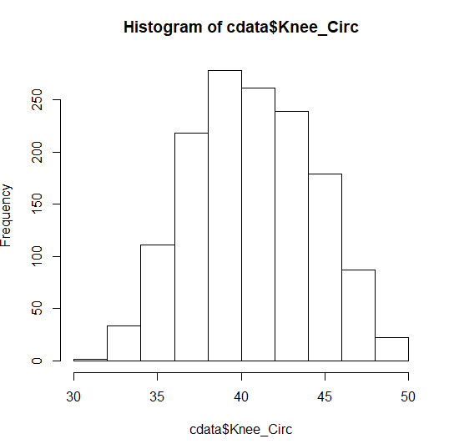 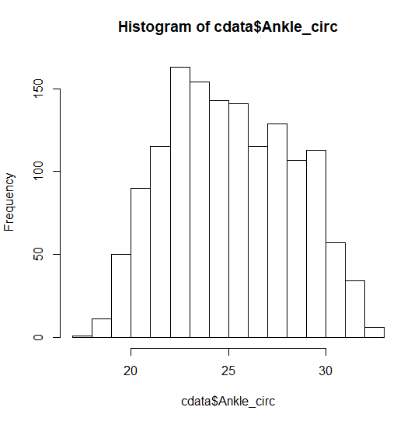 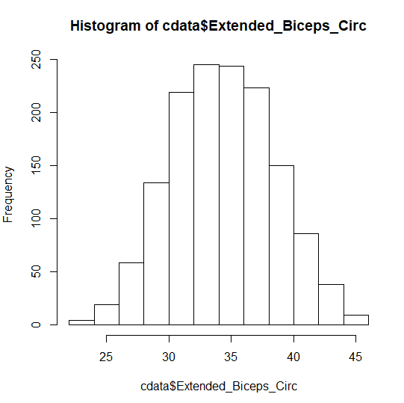

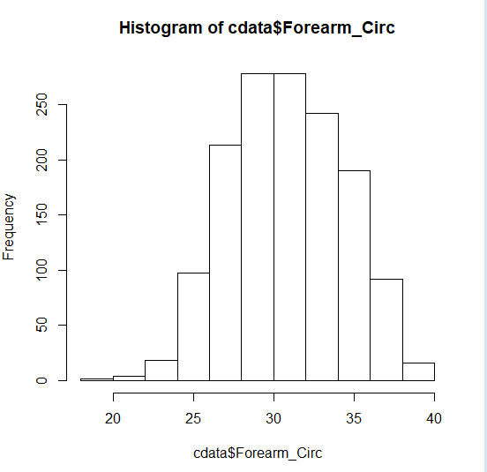

Modeling:

Spiriting data (80% Training and 20% Validation)

data=read.csv(file.choose(),)

dt = sort(sample(nrow(data),nrow(data)*.8))

train_dt = data[dt,]

test_dt = data[-dt,]

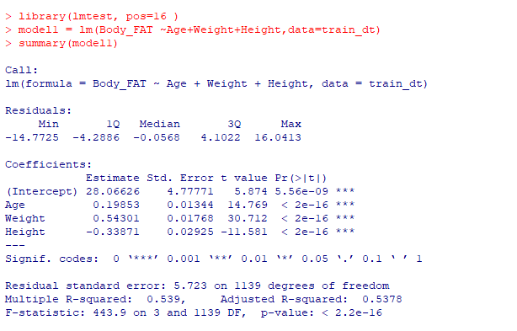

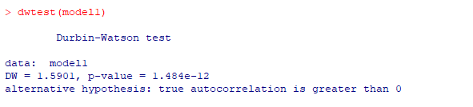

Prediction using Test data:

m1_predict=predict(model1,test_dt)



MAPE:



feture data :

ex : if paient age 45, height 167, weight 67 kgs what is bodyfat followed by model 1

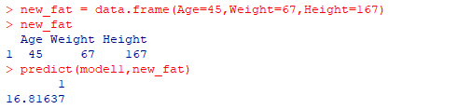

Model 2:

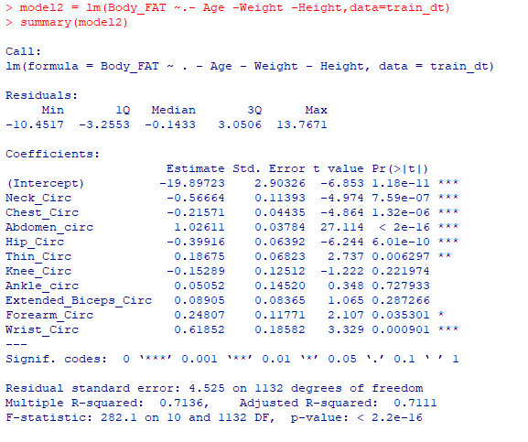

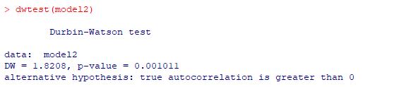

Improving Model 2 by eliminating VIF:

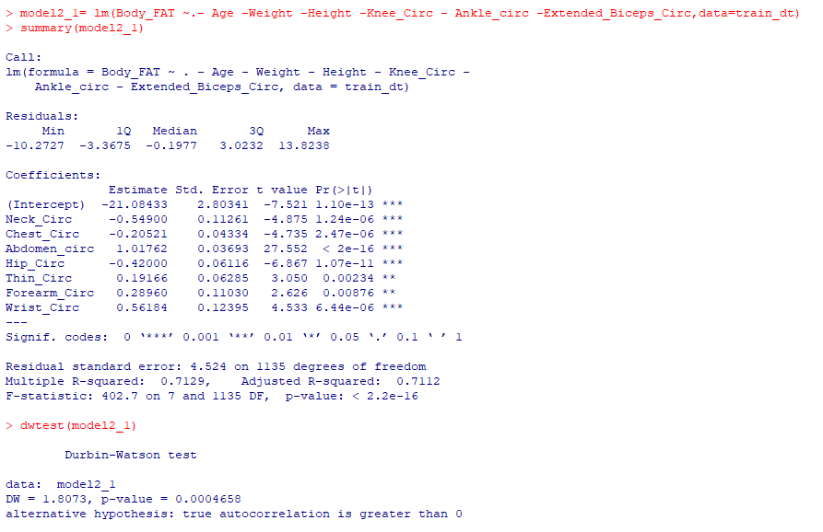

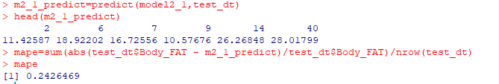

Improving Model 2 by eliminating VIF_2:

